|  |  |
| --- | --- |
| **EX NO: 3** | **EXAM REGISTRATION SYSTEM** |

**USE CASE DIAGRAM:**

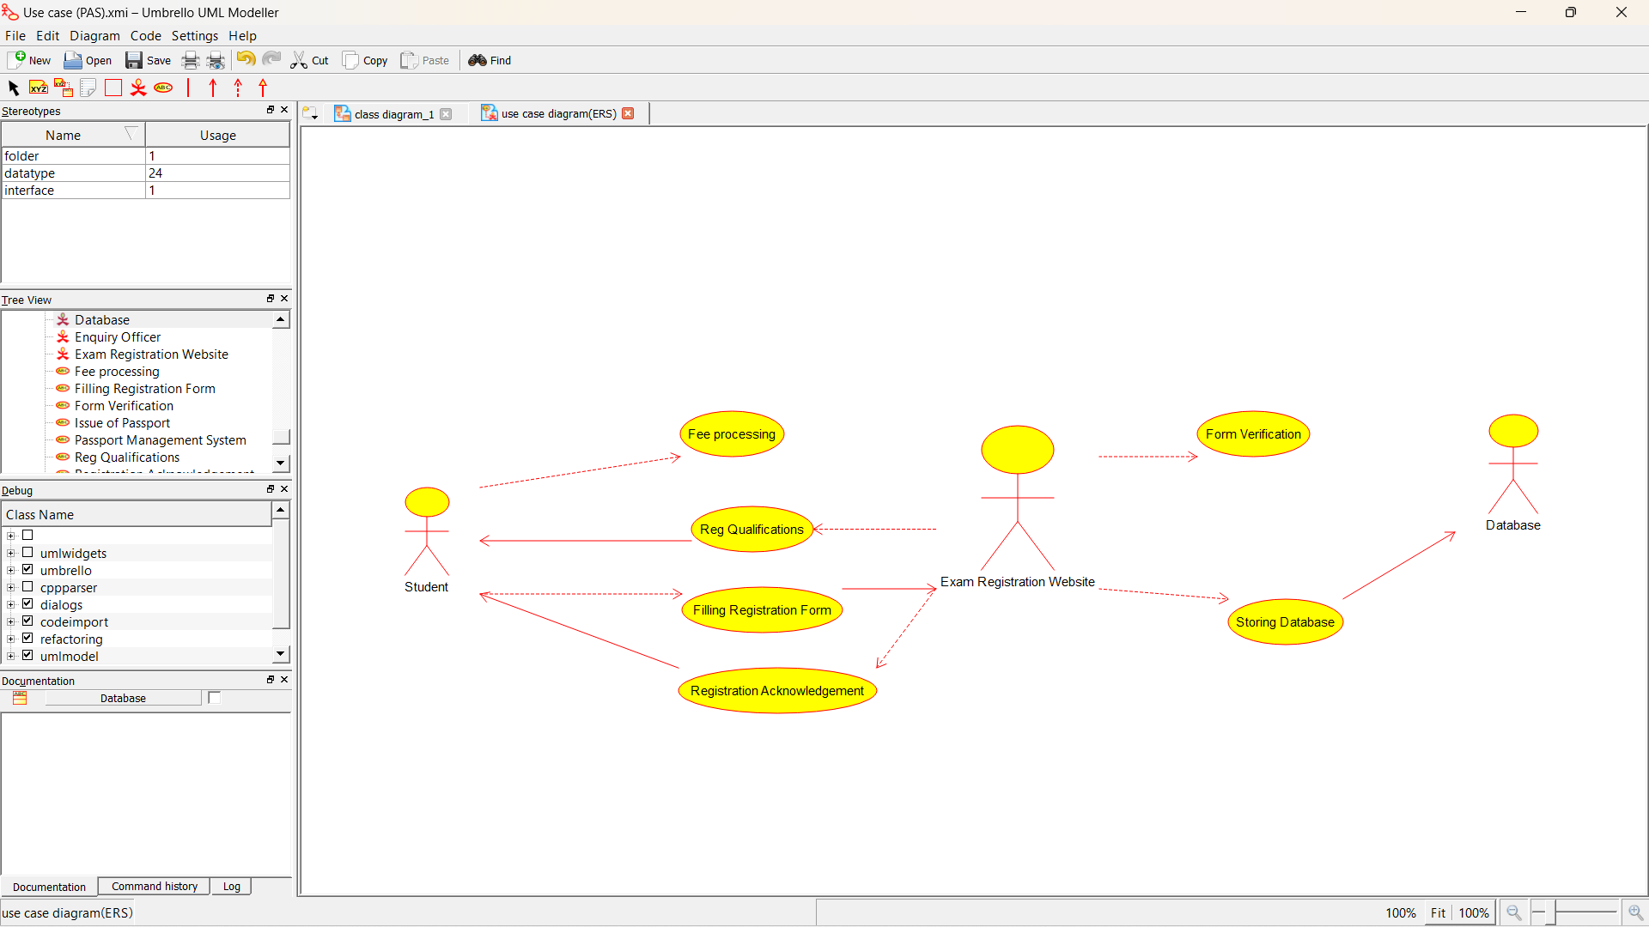

CLASS DIAGRAM: 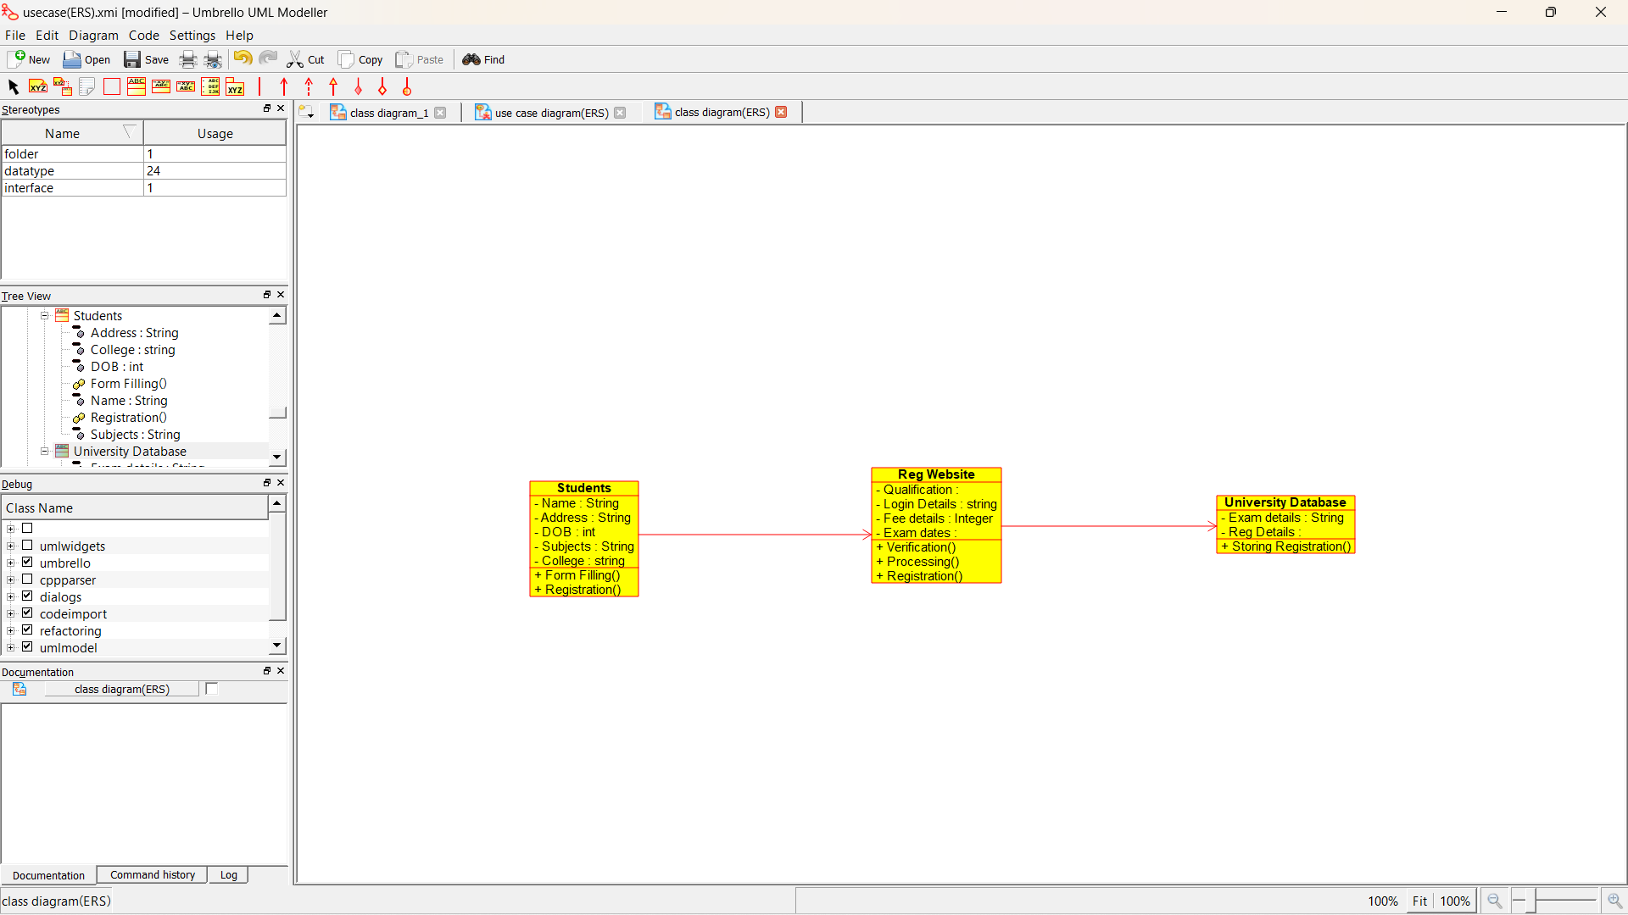

ACTIVITY DIAGRAM:

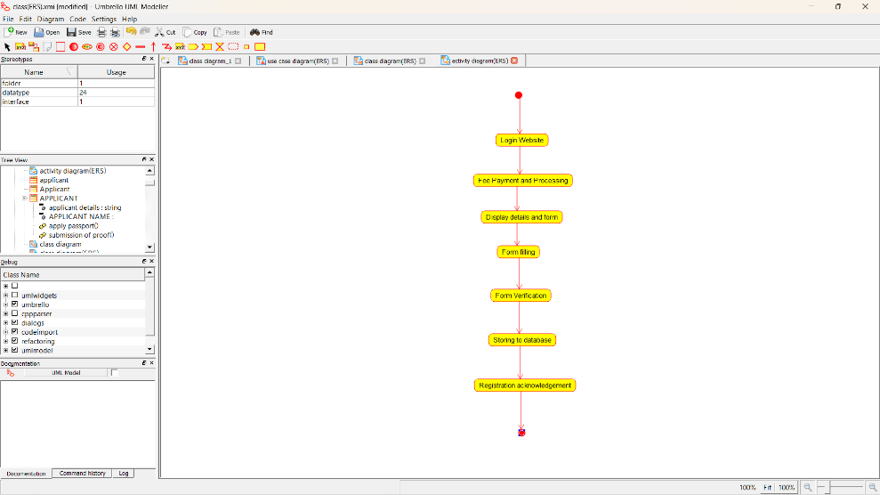

SEQUENCE DIAGRAM:

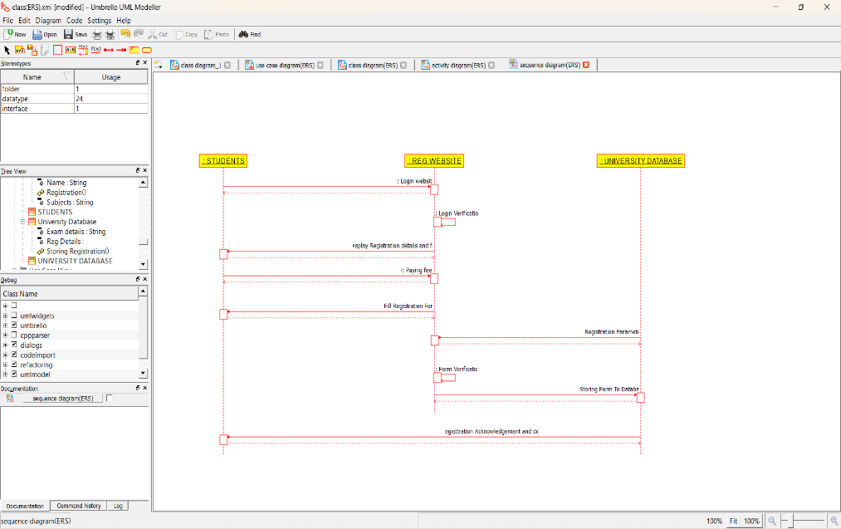

COLLABORATION DIAGRAM:

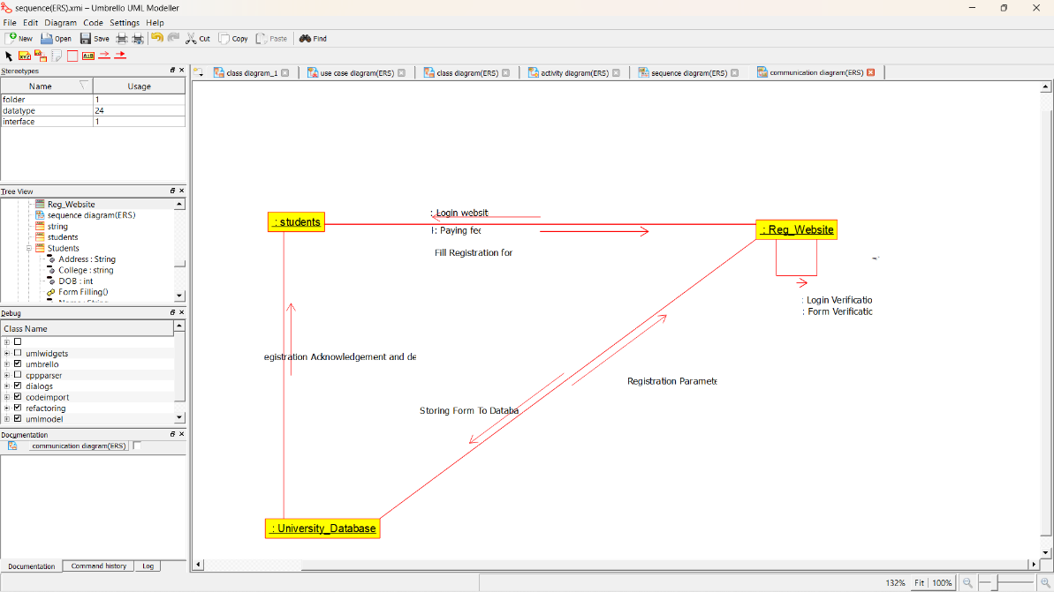

STATE DIAGRAM:

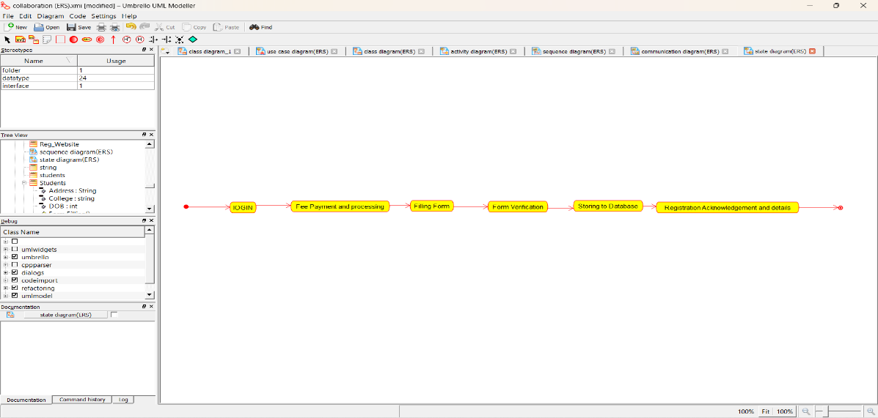

COMPONENT DIAGRAM:

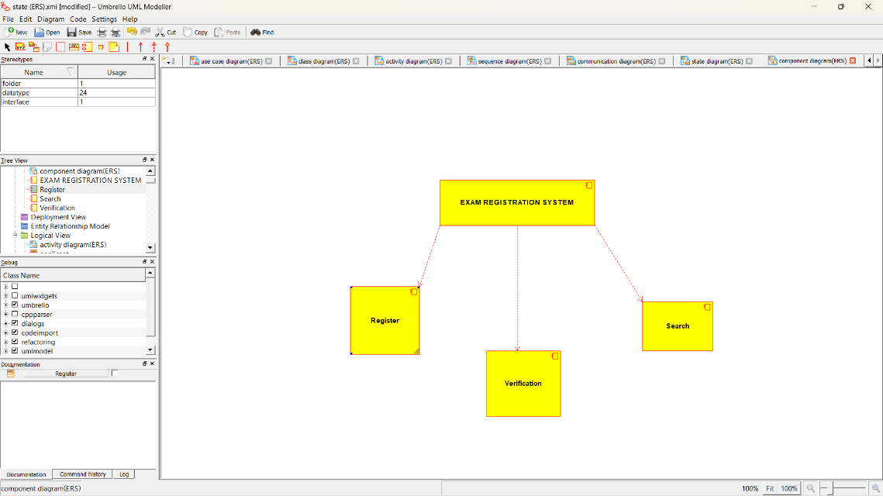

DEPLOYMENT DIAGRAM: 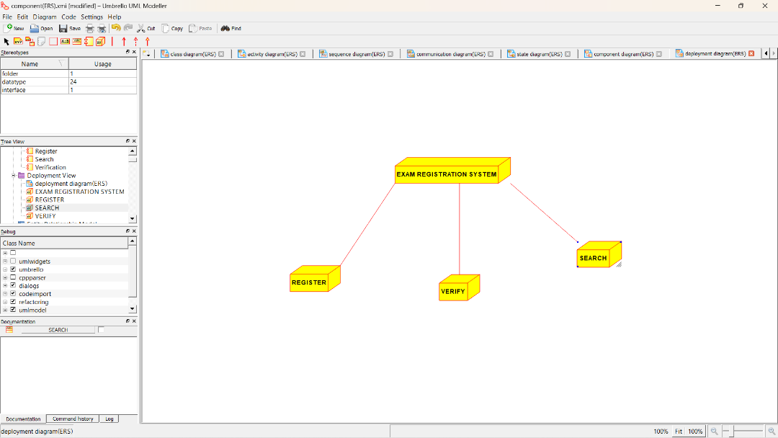

*PROGRAM CODING:*

Class Students

*/

public class Students {

//

// Fields

//

private String Name;

private String Address;

private int DOB;

private String Subjects;

private String College;

//

// Constructors

//

public Students () { };

//

// Methods

//

//

// Accessor methods

//

/**

* Set the value of Name

* @param newVar the new value of Name

*/

private void setName (String newVar) {

Name = newVar;

}

/**

* Get the value of Name

* @return the value of Name

*/

private String getName () {

return Name;

}

/**

* Set the value of Address

* @param newVar the new value of Address

*/

private void setAddress (String newVar) {

Address = newVar;

}

/**

* Get the value of Address

* @return the value of Address

*/

private String getAddress () {

return Address;

}

/**

* Set the value of DOB

* @param newVar the new value of DOB

*/

private void setDOB (int newVar) {

DOB = newVar;

}

/**

* Get the value of DOB

* @return the value of DOB

*/

private int getDOB () {

return DOB;

}

/**

* Set the value of Subjects

* @param newVar the new value of Subjects

*/

private void setSubjects (String newVar) {

Subjects = newVar;

}

/**

* Get the value of Subjects

* @return the value of Subjects

*/

private String getSubjects () {

return Subjects;

}

/**

* Set the value of College

* @param newVar the new value of College

*/

private void setCollege (String newVar) {

College = newVar;

}

/**

* Get the value of College

* @return the value of College

*/

private String getCollege () {

return College;

}

//

// Other methods

//

/**

*/

public void Form_Filling()

{

}

/**

*/

public void Registration()

{

}

}

/**

* Class Reg_Website

*/

public class Reg_Website {

//

// Fields

//

private void Qualification;

private String Login_Details;

private Integer Fee_details;

private void Exam_dates;

//

// Constructors

//

public Reg_Website () { };

//

// Methods

//

//

// Accessor methods

//

/**

* Set the value of Qualification

* @param newVar the new value of Qualification

*/

private void setQualification (void newVar) {

Qualification = newVar;

}

/**

* Get the value of Qualification

* @return the value of Qualification

*/

private void getQualification () {

return Qualification;

}

/**

* Set the value of Login_Details

* @param newVar the new value of Login_Details

*/

private void setLogin_Details (String newVar) {

Login_Details = newVar;

}

/**

* Get the value of Login_Details

* @return the value of Login_Details

*/

private String getLogin_Details () {

return Login_Details;

}

/**

* Set the value of Fee_details

* @param newVar the new value of Fee_details

*/

private void setFee_details (Integer newVar) {

Fee_details = newVar;

}

/**

* Get the value of Fee_details

* @return the value of Fee_details

*/

private Integer getFee_details () {

return Fee_details;

}

/**

* Set the value of Exam_dates

* @param newVar the new value of Exam_dates

*/

private void setExam_dates (void newVar) {

Exam_dates = newVar;

}

/**

* Get the value of Exam_dates

* @return the value of Exam_dates

*/

private void getExam_dates () {

return Exam_dates;

}

//

// Other methods

//

/**

*/

public void Verification()

{

}

/**

*/

public void Processing()

{

}

/**

*/

public void Registration()

{

}

}

/**

* Class University_Database

*/

public class University_Database {

//

// Fields

//

private String Exam_details;

private void Reg_Details;

//

// Constructors

//

public University_Database () { };

//

// Methods

//

//

// Accessor methods

//

/**

* Set the value of Exam_details

* @param newVar the new value of Exam_details

*/

private void setExam_details (String newVar) {

Exam_details = newVar;

}

/**

* Get the value of Exam_details

* @return the value of Exam_details

*/

private String getExam_details () {

return Exam_details;

}

/**

* Set the value of Reg_Details

* @param newVar the new value of Reg_Details

*/

private void setReg_Details (void newVar) {

Reg_Details = newVar;

}

/**

* Get the value of Reg_Details

* @return the value of Reg_Details

*/

private void getReg_Details () {

return Reg_Details;

}

//

// Other methods

//

/**

*/

public void Storing_Registration()

{

}

}